***System Design Group Project***

***Project Proposal***

***Group Members***

*Muhammad Ijlal 14031197*

*Muhammad Mudassir 14031238*

*Faheem Abbas Shah 13031162*

*Muhammad Asad 14031193*

***Monday, February 20, 2017***

# ABSTRACT:-

Wearable health detection devices are becoming a popular due to their portability. This paper proposes a similar device for the use of common people. There were several ways adopted for the production of the wearable health detection devices. Our Device by using pulse sensor and accelerometer will detect the heartrate, distance covered, speed and calories burnt. The data will be displayed on an LCD screen and can also be copied and displayed in the form of a graph. The solution will try to keep an equilibrium between the functionality provided and the cost.

Table of Contents

ABSTRACT:- 1

Introduction 3

System Requirements 3

Literature review 4

Existing Systems 4

Available Technologies 4

Proposed Solution 5

Components Required 5

Work Breakdown Structure 5

References 5

# Introduction

Portable health and fitness systems are a step towards a healthy word. Due to the portability, it has become easier than ever to track the health and workout routines and produce effective exercise plans to achieve better health. Previously, people used to buy expensive treadmills which provided the features of displaying heart rate and other similar measurements during exercise. But the use of treadmill is limited to indoor and for running only. With these portables devices one can have the same features anywhere and during different type of workouts. In this project we are going to provide a similar solution that can help an individual in keeping a track of his health and fitness. The main idea of the project is to design a wearable device which along with the functionalities of displaying current time and date in real time, can also provide health related information. The device should be capable of accurately measuring the heartbeat. It should also be able to provide information regarding the number of steps taken and calories burnt. For athletes it can include lap time, speed and workout planning capabilities.

# System Requirements

The minimal system capabilities include

1. Displaying current time and date.
2. Measuring and displaying heart rate with an accuracy of ${}_{-}^{+}{1 }$ bpm.
3. Displaying the speed and distance covered with an accuracy of ${}_{ -}^{+}2 \%$.
4. Recording and preparing a graphical report from the data.

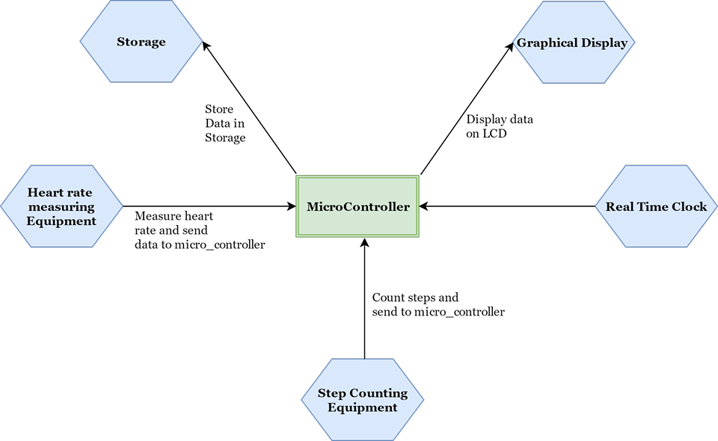

Fig 1 (Function Requirements)

# Literature review

## Existing Systems

A number of systems are already present which provide this functionality. “fitbit**”** a health and fitness company has provided many solutions of different types for different users [1]. There products provide quality experience but the prices are quite high for a normal user. Similarly, Under Armour Health box is another quality product which includes a bundle of other features like weight measurement [2]. But same as the former the price is quite high. This device uses chest strap for the measurement of heart rate which has known to impede training activities. Gym watch sensor is another product lying in this category [3]. The device’s price is considerably low compared to the previously mentioned devices but the functionality gets limited to certain indications regarding gym workout only. The aim of our project is to introduce a product for a normal daily life user i.e. build a system keeping an equilibrium between the functionality provided and the cost of the product.

## Available Technologies

To design the product with these functionalities a number of sensors and microcontrollers are required. There are number of options available to perform the required tasks. The heartbeat of a person can be measured from chest, wrist and finger. The pressure sensors and infrared light sensors can be used for this purpose [4] [5]. The option of measuring the heart rate using infrared light from finger proves to be the most effective approach because of its accuracy and ease of use [6]. Similarly, the cadence can be measured using pressure sensors or accelerometer [7]. The effective candidates in microcontroller technology are Arduino Uno and Arduino Nano.

# Proposed Solution

The solution proposed by our team includes the use of Arduino Uno and Arduino Nano along with some sensors and a color display. A real time clock will be used to provide the functionality of current time and date. Using the pulse sensor the heartbeat will be measured which will be sent to Arduino using wired connections. Similarly, the accelerometer, to be worn at the foot, will measure the number of steps taken by the user. Using an Arduino Nano and a Bluetooth module the data of the accelerometer will be sent to the Arduino Uno. Using the data from the two sensors Arduino Uno will calculate certain values like distance, speed, calories burnt and heart rate. The data will be displayed to the user using a color LCD. The system can be worn on wrist and won’t impede training activites.

## Components Required

1. 1x Arduino Uno
2. 1x Arduino Nano
3. 2x Bluetooth Modules
4. 1x Pulse Sensor
5. 1x Accelerometer
6. 1x Real Time Clock
7. 1x Color LCD

## Block Diagram

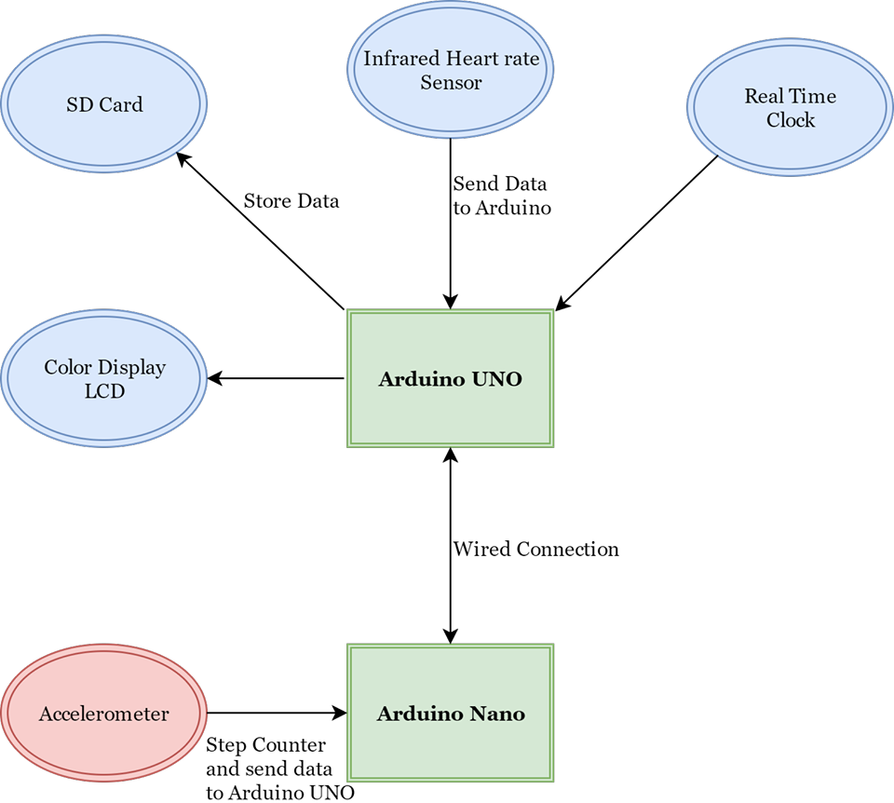

Fig 2 (Proposed Solution)

# Work Breakdown Structure

The whole project is to be completed in 12 weeks. The project is divided according to the following chart Fig 3.

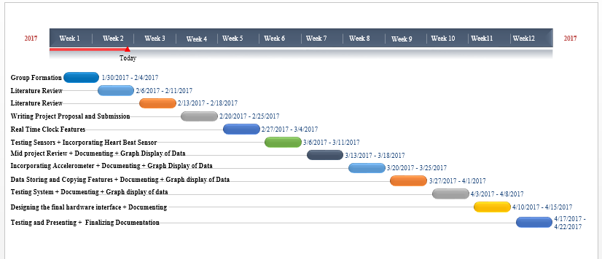

Fig 3 (Gantt Chart)

# References

|  |  |
| --- | --- |
| [1] | I. Fitbit, "fitbit," [Online]. Available: http://www.fitbit.com/home. [Accessed 20 February 2017]. |
| [2] | "Under Armour Healthbox," Under Armour®, Inc., [Online]. Available: https://www.underarmour.com/en-us. [Accessed 20 February 2017]. |
| [3] | Wurzelwerk, "Smart Strenght Traning to Go," GymMatch, [Online]. Available: https://www.gymwatch.com/en/. [Accessed 20 February 2017]. |
| [4] | T. W. K. M. Nicholas Constant, "Pulseband: A Hands-on Tutorial on How to Design a Smart Wristband to Monitor Heart-Rate," ieee.org, 2014. |
| [5] | M. T. I. P. I. A. a. A. R. Nazmus Saquib, "Measurement of Heart Rate Using Photoplethysmography," Department of Computer Science and Engineering Bangladesh University of Engineering and Technology, Dhaka, Bangladesh. |
| [6] | A. K. P. Bandana Mallick, "HEART RATE MONITORING SYSTEM," *International Journal of Science, Engineering and Technology Research (IJSETR),* vol. 5, no. 1, 2016. |
| [7] | K. H. a. T. S. Davrondzhon Gafurov, "Biometric Gait Authentication Using Accelerometer Sensor," *JOURNAL OF COMPUTERS,* vol. 1, no. 7, 2006. |